Name: Nishtha Rani

Project Name: Incredible India

Database Name: Project

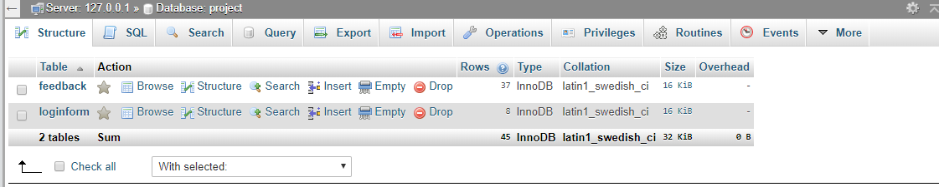

Table Name:

1. feedback

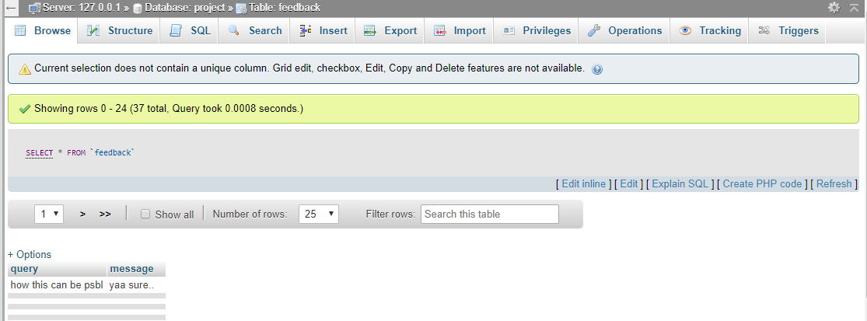

1. loginform

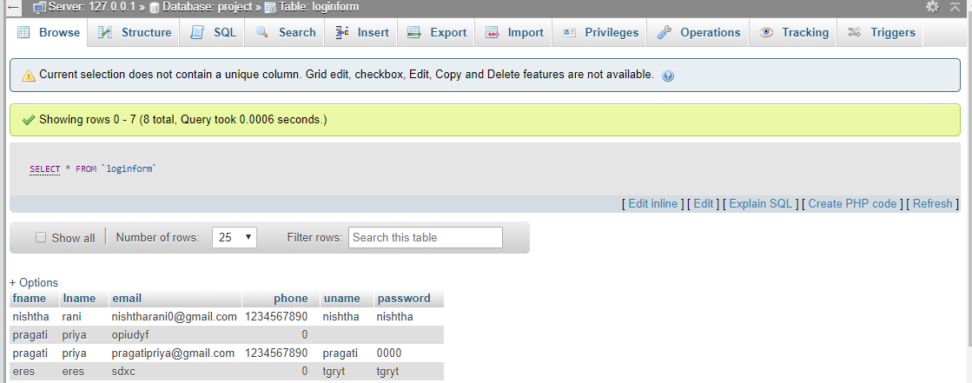

Contact Page:

contact.php

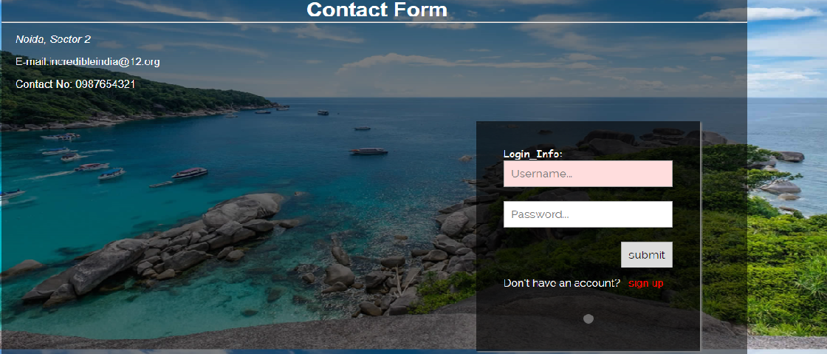

Redirecting Page:

query.php

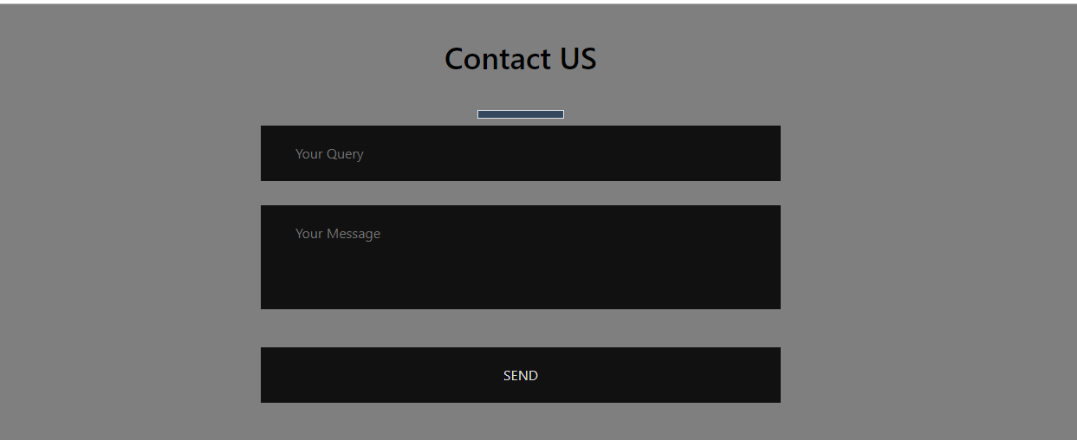

Signup form:

signup.php

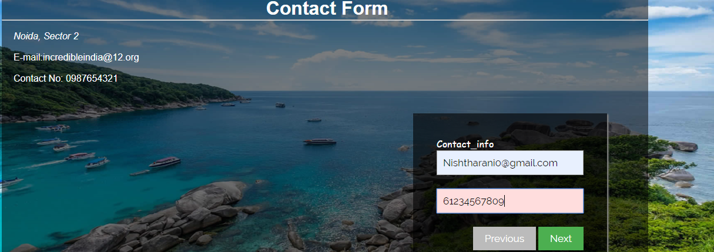

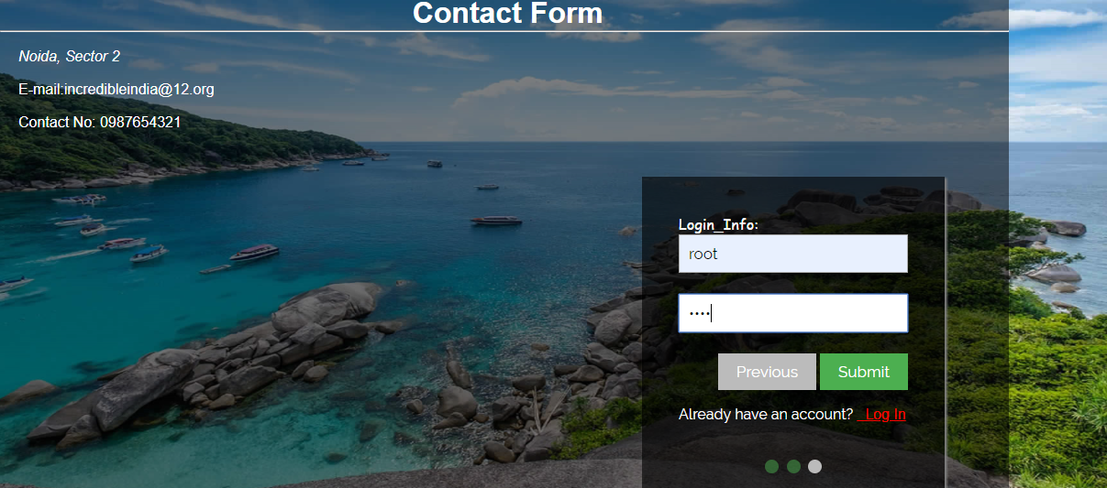

Signup Redirecting Page:

query.php



Query/Feedback Redirecting Page:

1. contact.php



Home Page:

index.php

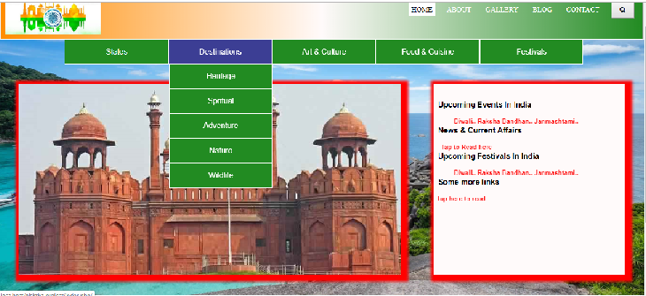

About Page:

about.php

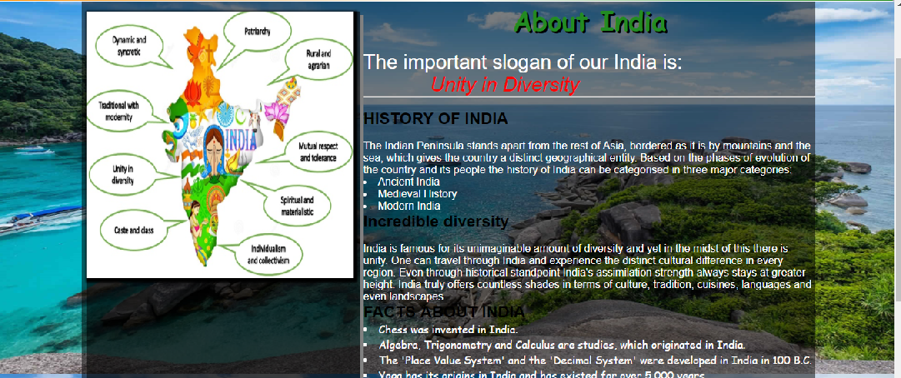

Gallery:

gallery.php

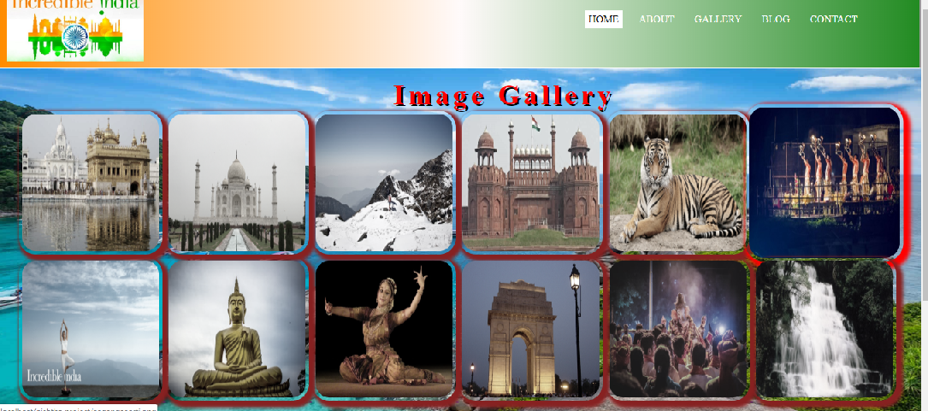

Gallery Redirecting Page: (when click on any photo)



Blog Page:

blog.php

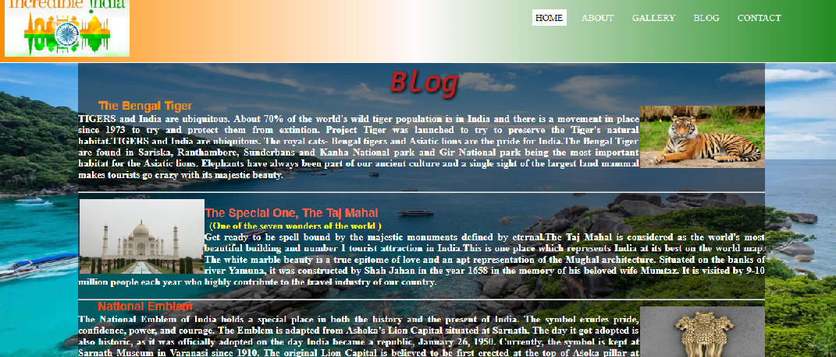

Contact Page:

contact.php

